Standalone applications> what are those (desktop apps)?
3 types of applications: desktop, mobile and web.
Types of servers
The client sends a request to the server.
The server gets the request, processes it and sends back a response to the client
API (Application Programming Interface): is like a messenger that helps two programs or systems talk to each other and share information.
Steps to build a system in real environment:
- Build the Data Base
- Build the API (since we already have some data)
- Build the Frontend
For testing purposes, you can start testing whatever is ready but if the frontend is not connected to the API doesn’t make sense to test it.
Difference between put and patch html methods
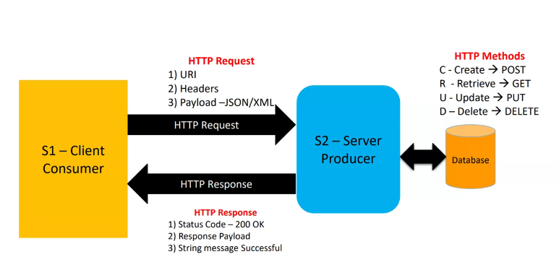
What to check while testing APIs:
- Status Code
- Response Time
- Response/Request Size
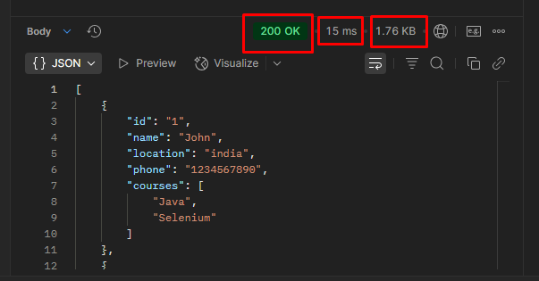
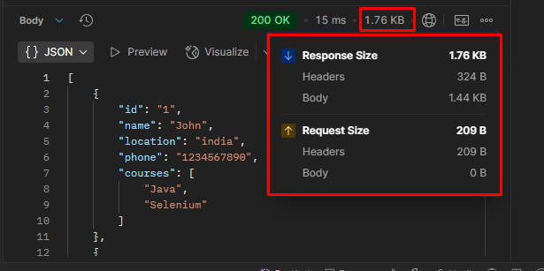
Also:
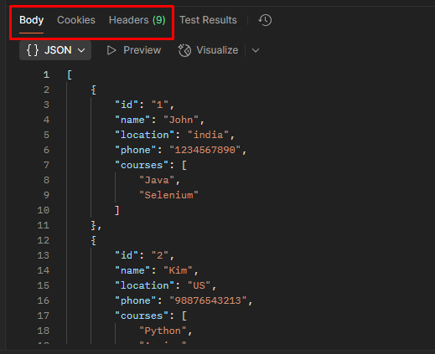
JSON Path is like the Xpath in XML files, to locate parts of the JSON (Javascript Object Notation).

JSON Path:
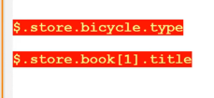
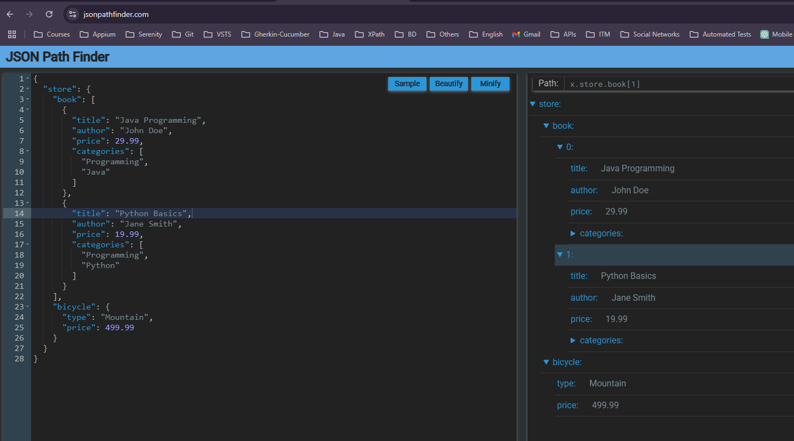

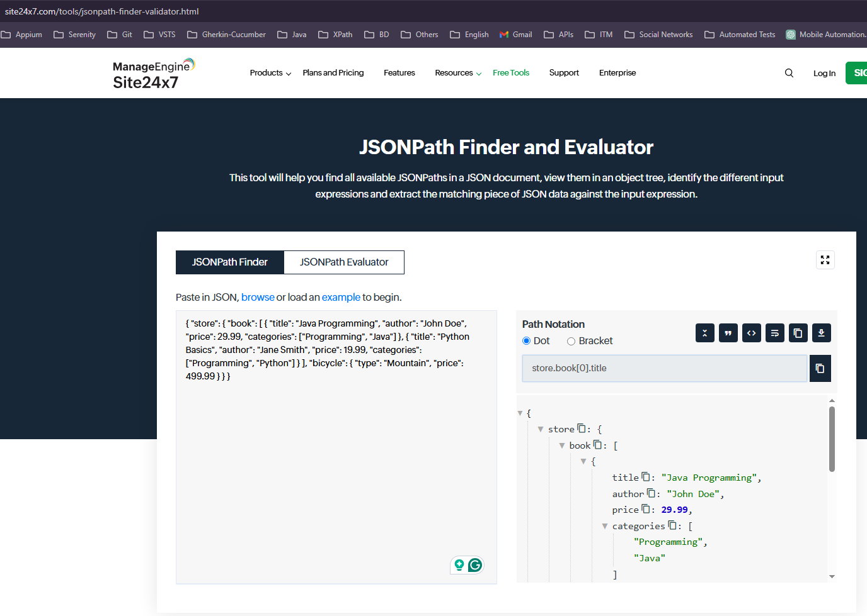

Data Base Testing:
- https://www.youtube.com/watch?v=Q3SnLBVWOGI&list=PLUDwpEzHYYLtmxThtmsBxocKuicJOddGj
2) https://www.youtube.com/watch?v=FvDd5-UFaoo&list=PLIMhDiITmNrIqwyYdLRnm5vHBeIkOKPGn
3) https://www.youtube.com/watch?v=AA3mvKlR8-8
https://www.youtube.com/watch?v=E2t5XbWwj7I&list=PLL34mf651faM_nn8uKlnwbQPw5zSh_F84

